Report
on
Training Workshop on Good Service Practices in Refrigeration and Air-conditioning (RAC) of 58th and 59th Batches

Background
HCFCs are used in refrigeration and foam applications in Bangladesh. There are limited quantities used in fire-fighting and solvent applications and no reported use in aerosols. A large amount of HCFC-22 is consumed in the manufacturing and assembly of residential air-conditioning (RAC) units. The refrigeration servicing sector has grown considerably over the last decade. With regard to the servicing sector, refrigeration servicing workshops in Bangladesh can be categorized as small, medium and large. As per the 2011 survey results, there are more than 15,000 refrigeration servicing workshops that employ about 3-4 service technicians each. The total number of these technicians is estimated to be around 50,000 at a conservative level, mostly from the informal sector.
Technicians have the important role of making the operation of RAC systems the most energy efficient and decreasing refrigerant emissions as well as handling safety aspects properly. This can only be achieved by the adoption of good practices. The training was aimed to the evaluation with these problems. Our service technicians are not well trained and often they make some wrong doings. These can be avoided by providing them good service practice training. Experience service technicians will be more efficient and the loss or damage to the equipment and environment can be avoided through this type of training. After the training, technician should be should be able to achieve the following servicing operations:
- Right way of leak detection, purging and evacuation.
- Right way of charging refrigerants.
- Identifying the servicing-specific tubing tools and techniques, bending, flaring, swaging, piercing, pinching and welding.
- Identifying the proper use of servicing instruments: manifold gauges, charging scales, and thermometers etc.
- Good practice in servicing & installation of ACs.
Training on Good Service Practices in RAC at Dinajpur
Training workshop on “Good Service Practices in Refrigeration and Air-conditioning” was organized by the Department of Environment under HCFC Phase-out Management Plan – UNEP Component project during 27-30 November 2017 at Dinajpur during 9 am to 5 pm. The participants were refrigeration and air-conditioning (RAC) service technicians from Dinajpur and some participants are from Panchagar & Thakurgaon. The participants were divided into two batches. Each batch had two days long training on Good Service Practices in RAC sectors. 54 participants were attended in the first batch and 48 participants attended in the second batch. Participants with basic technical knowledge to handle air-conditioner and refrigerator were invited.
The objective of the workshop was to increase the capacity of the RAC technicians so that they don’t release the ozone depleting refrigerants in the atmosphere and thus contributing to combat ozone layer depletion.
During the workshop a set of five books on Refrigeration and Air-conditioning published by the Department of Environment was distributed among the participants along with some information sheets, posters on retrofitting refrigerator and informative book. Power point & multimedia presentation were used for fruitful learning. The training workshop was conducted interactively between the resource person and the participants.
Day-1 of the 58th Batch
The first day of the training workshop begins with the inaugural session. The inaugural session was started with the recitation from the holy Qur’an. Mr. Shaikh Obaidullah Al Mahmood, Research Officer, INS Phase-VII Project; Mr. Mostafa Kamal, President, Dinajpur Refrigeration Workshop Owners Association; Mr. Md. Akbar Ali, Vice-President, President, Dinajpur Refrigeration Workshop Owners Association; Mr. Abu Sayed Babul, Trainer, Mr. Md. Asaduzzaman, Trainer & Senior Vice-President, Bangladesh Refrigeration and Air-conditioning Merchant Association were present in that occasion. They highlighted the importance of the training workshop and ozone layer protection.
Technical session started soon after the inaugural session of the workshop. The core trainers were Mr. Md. Asaduzzaman and Mr. Abu Sayeed Babul. On the first day the trainers mainly focused on the following topics
- Environmental Impact and Human Health Impacts of ODS Refrigerants;
- Alternatives to HCFCs and their characteristics;
- Handling of HFCs refrigerants;
- Servicing of HCFC and HFC Based Air-conditioners;
- Tools & Equipment for servicing;
- Dos and Don’ts in Refrigeration & Air-Conditioning Servicing;
- Handling and Safety Issues of HC Refrigerants;
- Servicing of HC based Air-conditioners;
- Installation procedure of split air conditioners;
Video on servicing and installation procedure was shown. A recap on topics was conducted by Mr. Shaikh Obaidullah Al Mahmood.

Day-2 of the 58th Batch
The second day of the training workshop begins with the recap of the previous days topics. Mr. Md. Asaduzzaman and Mr. Abu Sayeed Babul were the trainers of second day. They covered the following topics:-
- Refrigerant Recovery, Recycling & cylinders;
- Economics of refrigerant Reclamation & Best Service;
- Contaminated refrigerants and Refrigerant Identifier;
- Selection & safe usage of cleaning solvents;
- Maximising Climate Benefits through servicing sector;
- Maximising Climate Benefits through servicing sector;
- Recovery Machine – Maintenance;
- Single Stage Vs. double stage nitrogen regulator;
Simulation video on refrigerant recovery and recycling was shown. A hands-on training on evacuation of the systems was conducted by Mr. Abu Sayeed Babul. A recap was conducted by Mr. Shaikh Obaidullah Al Mahmood on the second day topics.
Day-1 of the 59th Batch
The first day of the training workshop begins with the inaugural session. The inaugural session was started with the recitation from the holy Qur’an. Mr. Shaikh Obaidullah Al Mahmood, Research Officer, INS Phase-VII Project; Mr. Jahir Raihan, Secretary, Dinajpur Refrigeration Workshop Owners Association; Mr. Md. Akbar Ali, Vice-President, President, Dinajpur Refrigeration Workshop Owners Association; Mr. Abu Sayed Babul, Trainer, Mr. Md. Asaduzzaman, Trainer & Senior Vice-President, Bangladesh Refrigeration and Air-conditioning Merchant Association were present in the inaugural session. In their opening remarks respected guests discussed about the importance of training workshop and ozone layer protection.
Technical session took place after the inaugural session of the workshop. Mr. Md. Asaduzzaman and Mr. Abu Sayeed Babul were the core trainers of the training workshop. On the first day, detailed discussion made by trainers on the following topics:-
- Environmental Impact and Human Health Impacts of ODS Refrigerants;
- Alternatives to HCFCs and their characteristics;
- Handling of HFCs refrigerants;
- Servicing of HCFC and HFC Based Air-conditioners;
- Tools & Equipment for servicing;
- Dos and Don’ts in Refrigeration & Air-Conditioning Servicing;
- Handling and Safety Issues of HC Refrigerants;
- Servicing of HC based Air-conditioners;
- Installation procedure of split air conditioners;
Video on servicing and installation procedure was shown. A recap on topics was conducted by Mr. Shaikh Obaidullah Al Mahmood.
Day-2 of the 59th Batch
The second day of the training workshop begins with the recap of the previous day’s topics. Mr. Md. Asaduzzaman and Mr. Abu Sayeed Babul were the respective trainers of the second day. Following topics were covered by the trainers:-
- Refrigerant Recovery, Recycling & cylinders;
- Economics of refrigerant Reclamation & Best Service;
- Contaminated refrigerants and Refrigerant Identifier;
- Selection & safe usage of cleaning solvents;
- Maximising Climate Benefits through servicing sector;
- Maximising Climate Benefits through servicing sector;
- Recovery Machine – Maintenance;
- Single Stage vs. double stage nitrogen regulator;
Simulation video on refrigerant recovery and recycling was shown. A hands-on training on evacuation of the systems was conducted by Mr. Abu Sayeed Babul. A recap was conducted by Mr. Abu Sayeed Babul on the second day topics. A concluding session was followed at the end of the 59th batch training.
Concluding Session of 58th and 59th Batches
The concluding session for both batches was held on the fourth day of the workshop. Mr. Shaikh Obaidullah Al Mahmood, Research Officer, INS Phase-VII Project; Mr. Mostafa Kamal, President, Dinajpur Refrigeration Workshop Owners Association; Mr. Md. Akbar Ali, Vice-President, President, Dinajpur Refrigeration Workshop Owners Association; Mr. Jahir Raisan, Secretary, Dinajpur Refrigeration Workshop Owners Association; Mr. Abu Sayed Babul, Trainer, Mr. Md. Asaduzzaman, Trainer & Senior Vice-President, Bangladesh Refrigeration and Air-conditioning Merchant Association were also present at the closing session. Respective guests delivered their speeches at the closing session. Mr. Md. Asaduzzaman and other guests distributed certificates among the participants of two batches.

Some Pictures of Training Workshop
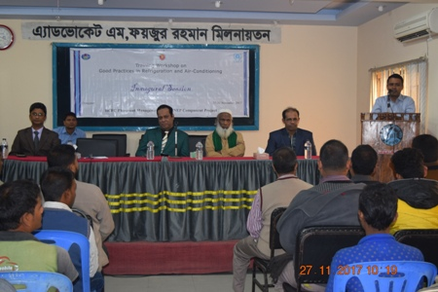
Inaugural Session of the 58th Batch of the Training.
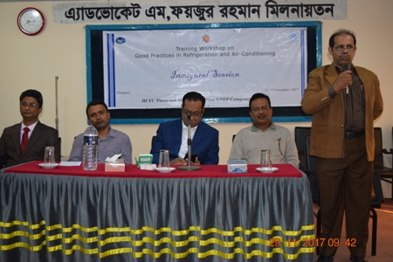
Mr. Akbar Ali, Vice President, Dinajpur Refrigeration Workshop Owners Association is giving his opening remarks.

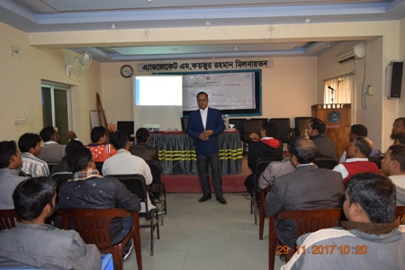
Technical session of the training workshop.
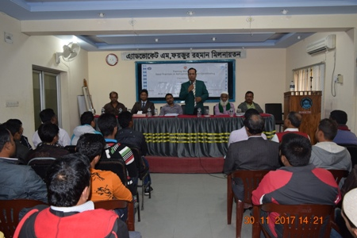
Hon’ble Guests at the Closing Session of the Workshop.
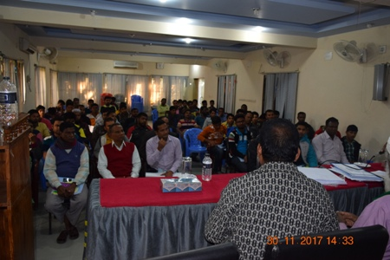
Participants of the Training Workshop.

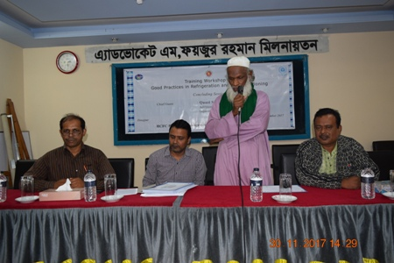
Mr. Mostafa Kamal, President, Dinajpur Refrigeration Workshop Owners Association is giving his opening remarks is giving his concluding remarks.
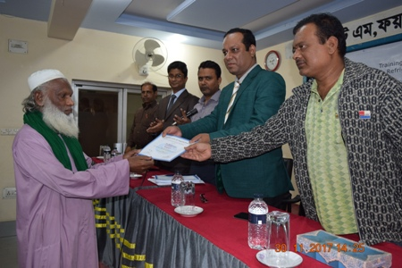
Participants of the Training Workshop Receive Certificates from the Hon’ble Guests.

