Training Program on
“Airmetrics MiniVol PM Sampler Operation and Maintenance”
(31 December 2012)

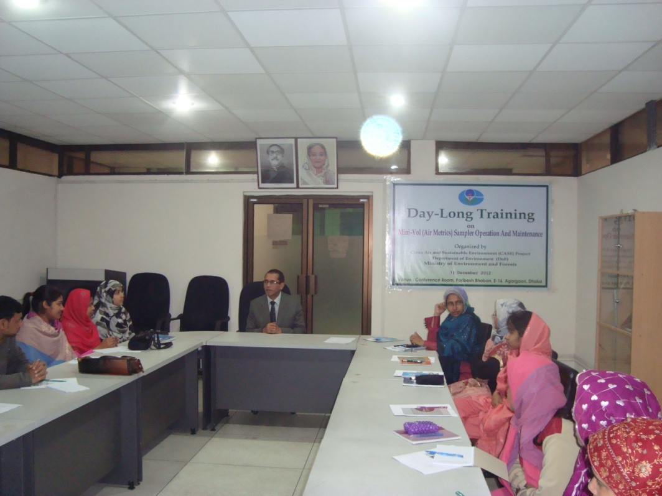

Clean Air and Sustainable Environment Project
Report on Training on
“Airmetrics MiniVol PM Sampler Operation and Maintenance”
(31 December 2012)

1.0 Introduction
One of the major activities under the Clean Air and Sustainable Environment [CASE] project was to develop human resources within the Department of Environment (DoE) for sustainability. Recently, 7 Airmetrics MiniVol PM samplers were provided to the DoE to enhance their monitoring capability. In view of the proper utilization of the samplers, a day-long training program on “Airmetrics MiniVol PM Sampler Operation and Maintenance” was organized for DoE technical staffs on 31 December 2012. A total of 20 participants attended the program. Mr. Shah Rezwan Hayat, Deputy Director, CASE Project welcome and presented brief overview of the training programme and wished that the DoE technical staffs will learn how to operate and maintain the PM samplers. The programme covered both theoretical and practical demonstration on the principle of operation of PM sampler.
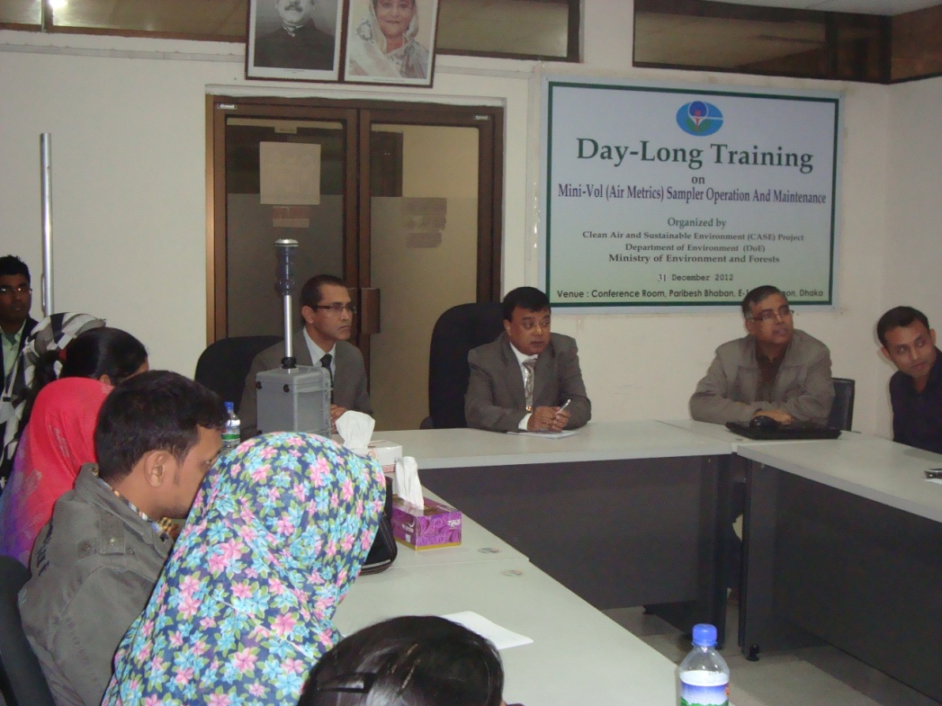
Closing Ceremony
Mr. A.M. Monsurul Alam, Director (Admin), Department of Environment was present in the closing ceremony and appreciated the effort of the CASE project in respect of holding such a Training programme and hope that it will be a great help towards capacity building in the DoE setup.

2.0 Objectives
The course objectives were to deliver theoretical lectures and provide hands on training on:

- Fundamentals of size fractionated particulate matter (PM) sampling

- Demonstrations on PM Sampling Techniques using Airmetrics MiniVol Sampler

- Hands-on Training on PM sampling

3. Venue
Theoretical lectures were delivered at the Conference Room (Shuli) of the CASE Project. The Demonstrations and Hand on training were provided at the CAMS site, BARC, Dhaka.

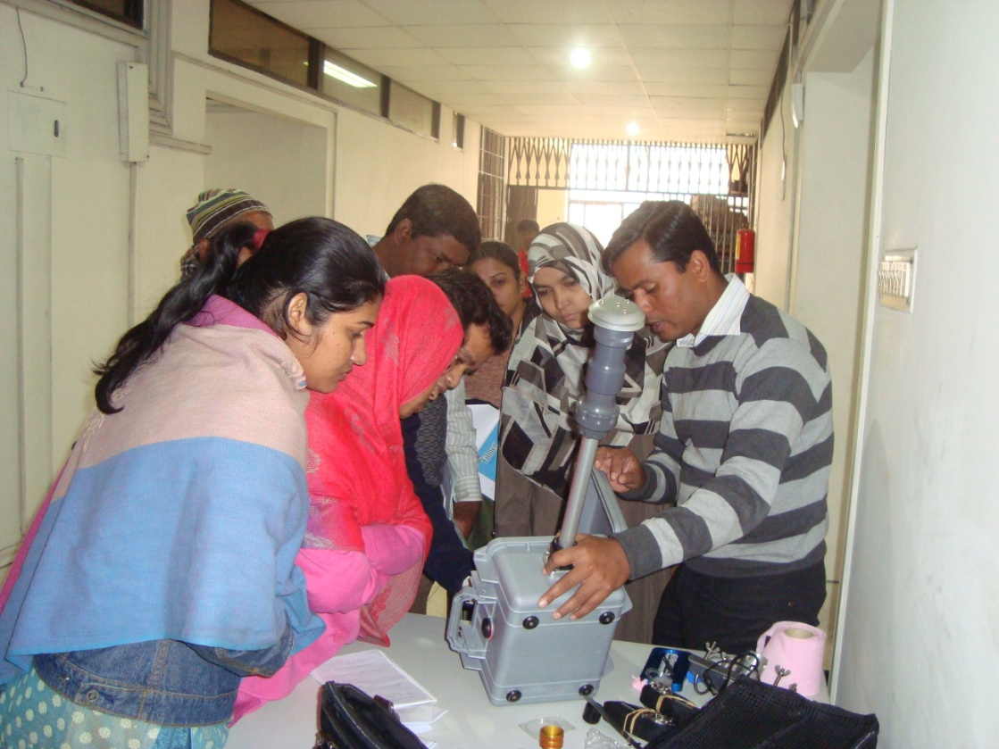
Hands-on Training Session

4. Methodology Used
The methodology used in the training includes class room lectures, presentation, discussion, and demonstration.

5. Resource Persons
The Course Director was Dr. Mohammad Nasiruddin, PD, CASE Project and Shah Rezwan Hayat, Deputy Director, CASE Project was Course Coordinator. The training sessions were conducted by Dr. S.K. Biswas, Consultant (Monitoring), CASE Project. Mr. Mizanur Rahman, Sr. Technician and Mr. Ashrafuzzaman, Technician, CASE Project conducted demonstration and hands-on training session.

Annexure A: List of Participants
Sl. No | Name | Designation & Organization
1. | Samar Kumar Paul | Inspector, Dhaka Metro, DoE
2. | Kazi Saifuddin | Inspector, Dhaka Metro, DoE
3. | Md. Zahirul Islam Talukder | Senior Chemist, DoE
4. | Shaheda Begum | Senior Chemist, DoE
5. | Sonia Afsana | Senior Chemist, DoE
6. | Rawshan Ara Ripa | Junior Chemist, DoE
7. | Md. Golam Rosul Khan | Junior Chemist, DoE
8. | Mst. Safia Akter | Laboratory Assistant, DoE
9. | Afroza Sultana | Sample Collector, DoE
10. | Mst. Gulshan Ara | Laboratory Assistant, DoE
11. | Dewan Md. Shalam | Sample Collector, DoE
12. | Md. Afsar Uddin | Laboratory Attendant , DoE
13. | Sharmin Akter | Laboratory Assistant, DoE
14. | Rima Akter | Sample Collector, DoE
15. | M.M. Habibur Rahman | Sample Collector, DoE
16. | Shahin Sultana | Inspector, DoE
17. | Most. Jesmin Akter | Inspector, DoE
18. | Nusrat Jahan | Laboratory Assistant, DoE
19. | Md. Moniruzzaman | Sample Collector, DoE
20. | Md. Ashrafuzzaman | Technician, DoE

